LAB Logbook

Lab 1
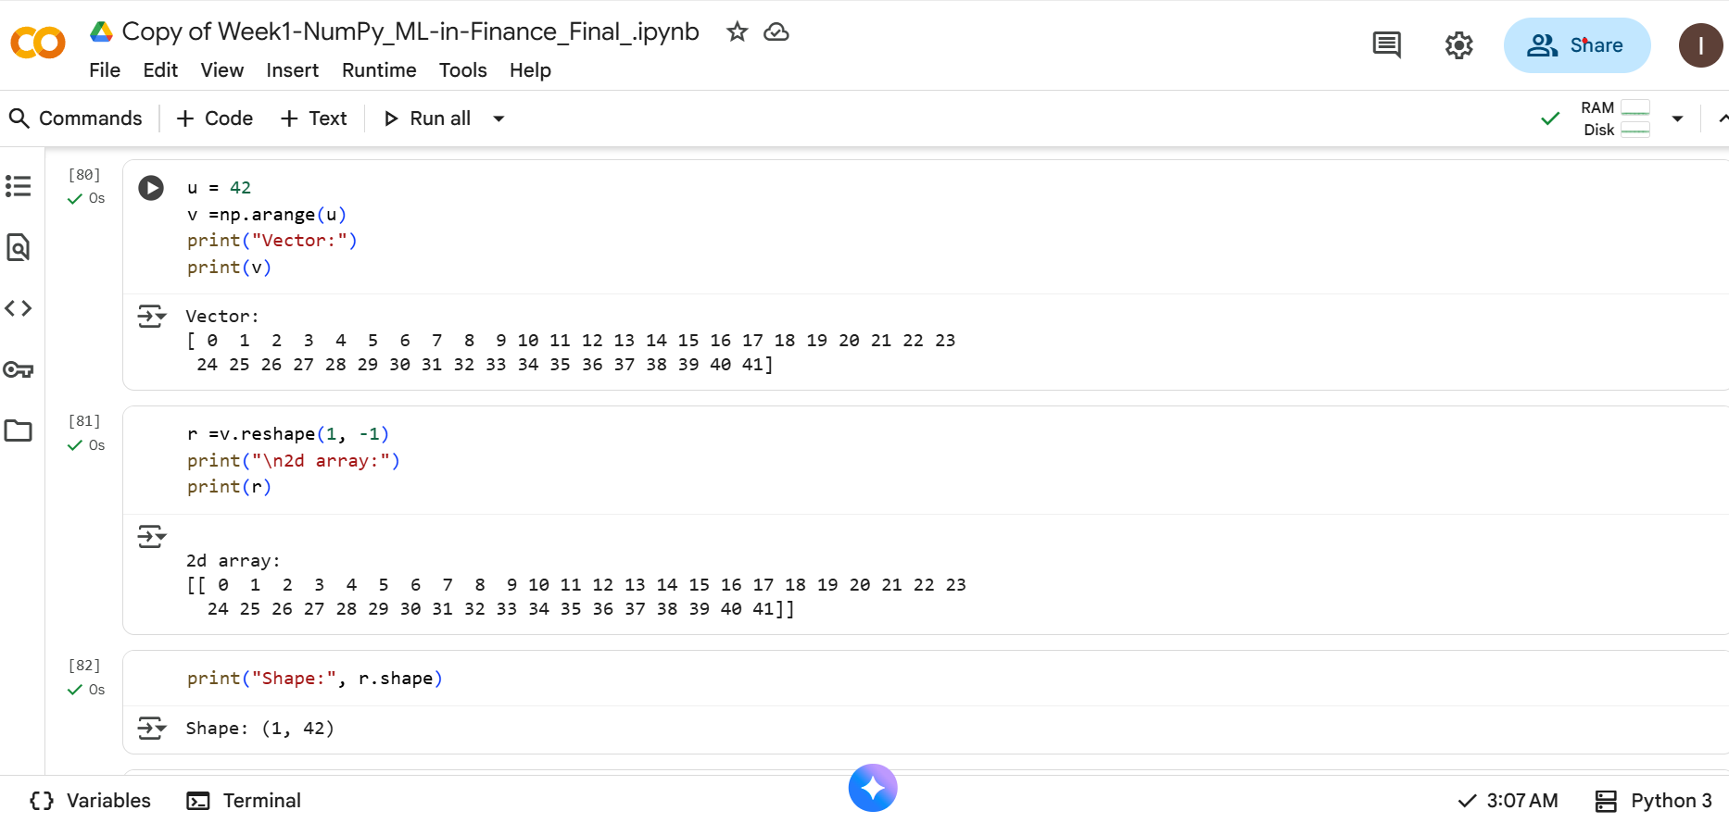
iankipchumba06-max/machine-learning-in-finance--assignment
Lab 2
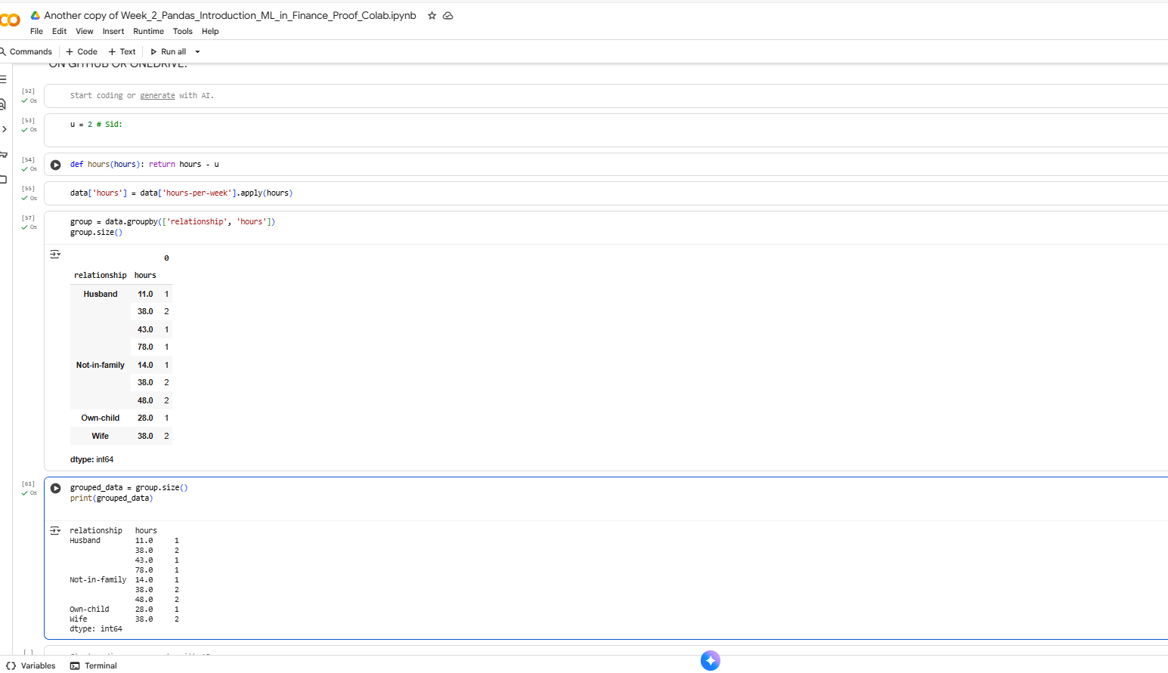
Another copy of Week_2_Pandas_Introduction_ML_in_Finance_Proof_Colab.ipynb - Colab

Lab 3
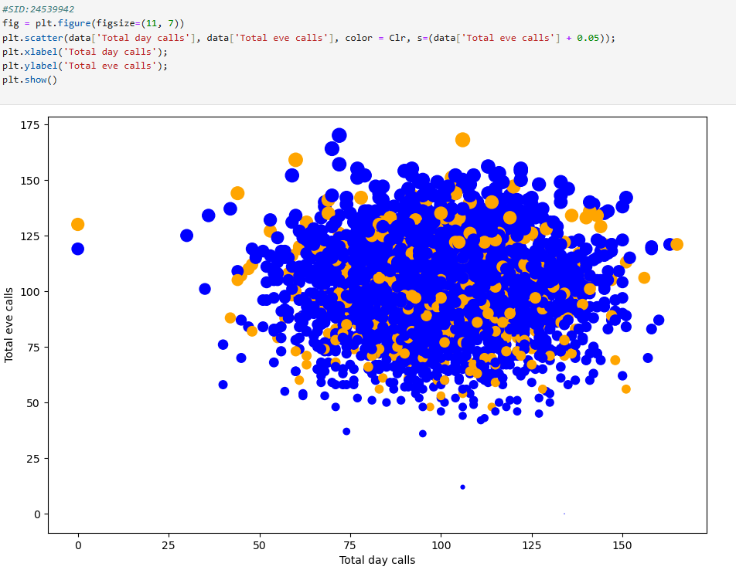
Week-3-Pandas-and-Seaborn_ML_in-Finance_Final
Lab 4
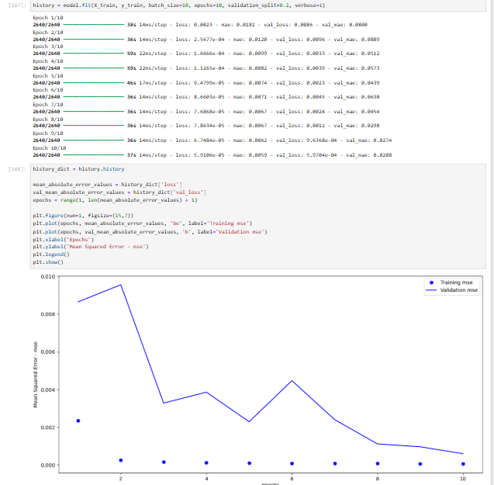

Week-4-MLP_S&P_ML_in-Finance_Final

Lab 5
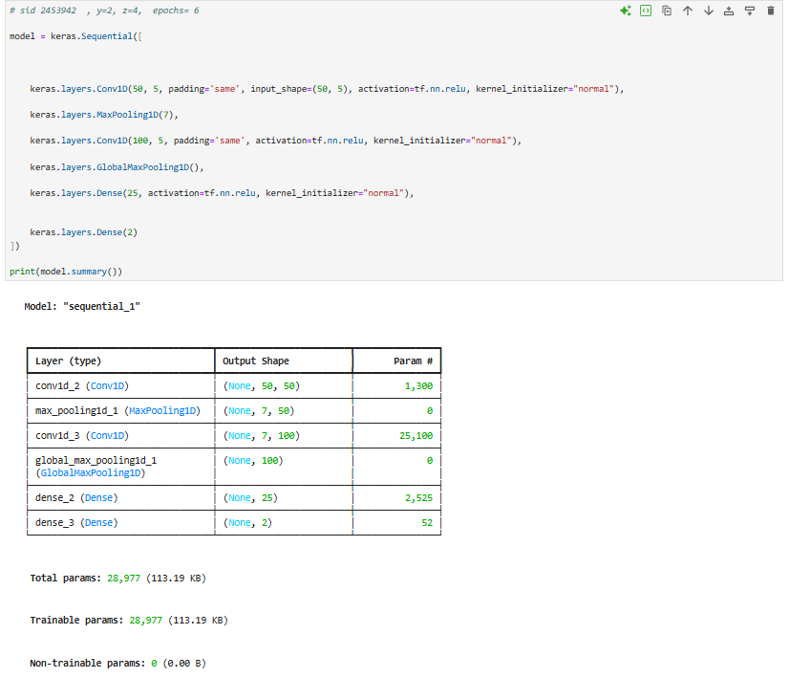
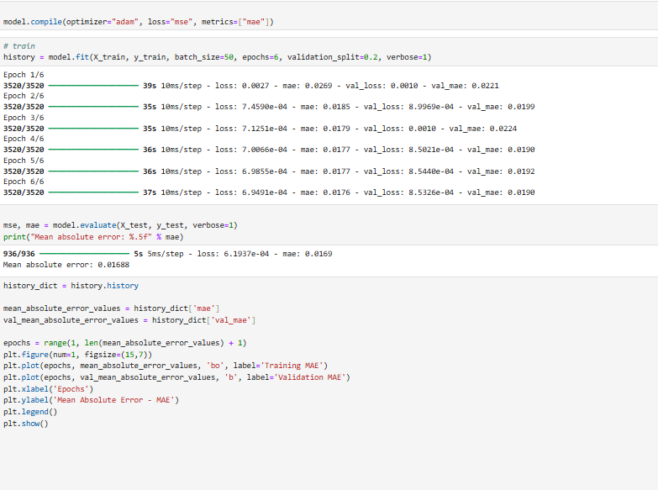
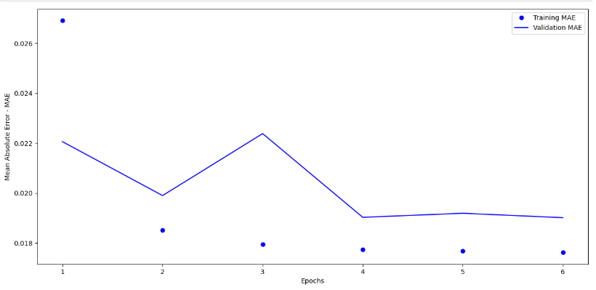

Week-5-CNN_EUR-USD_ML_in-Finance__Final
Lab 6

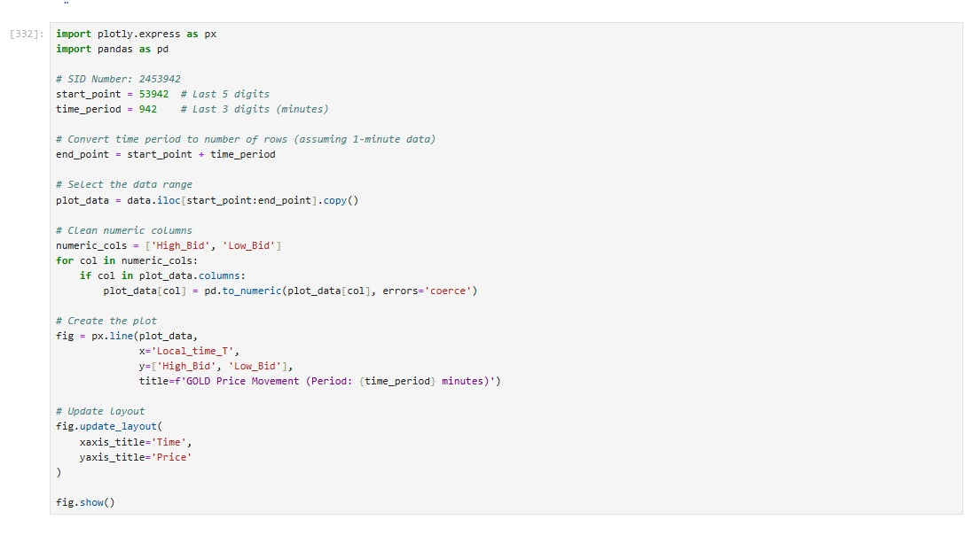
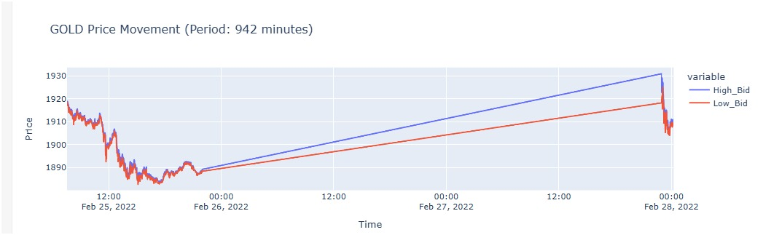

Lab 7
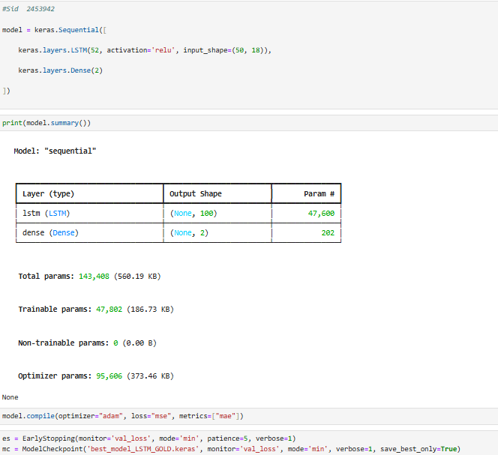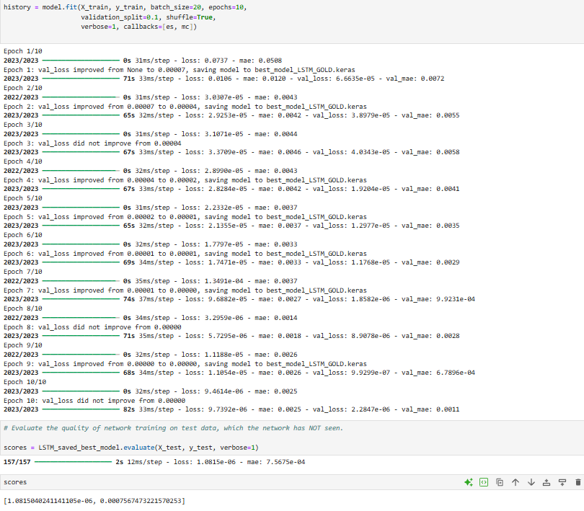
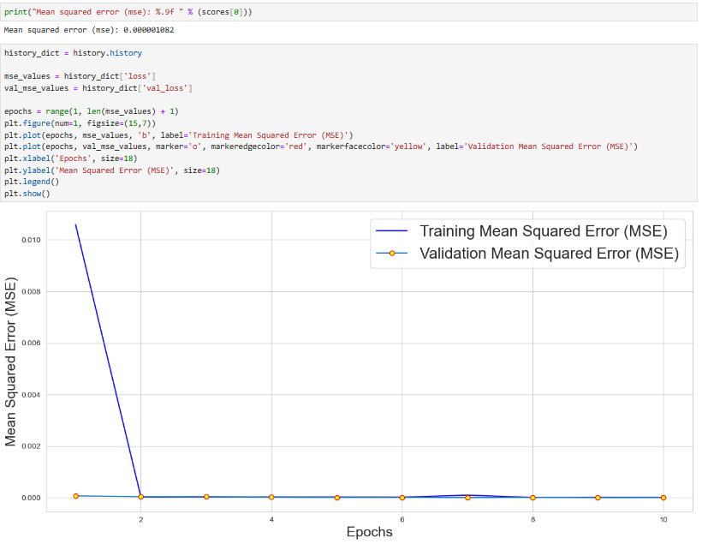
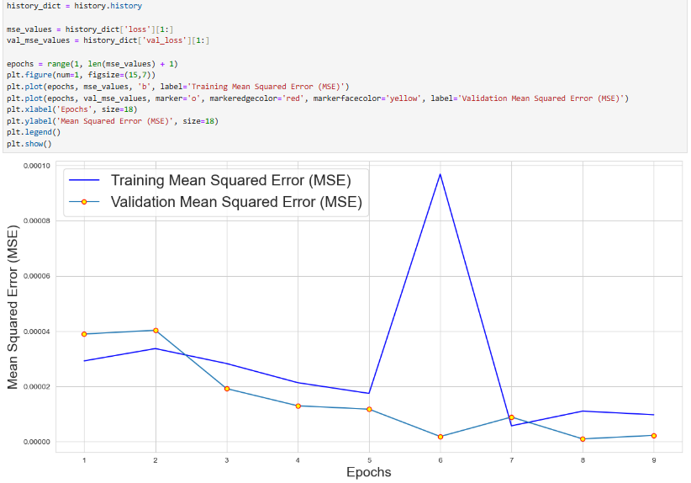

http://localhost:8801/notebooks/Week-7-LSTM_GOLD_during-5-minutes__EarlyStopping_ML_in-Finance__Final.ipynb?#:~:text=Week%2D7%2DLSTM_GOLD_during%2D5%2Dminutes__EarlyStopping_ML_in%2DFinance__Final

Lab 8
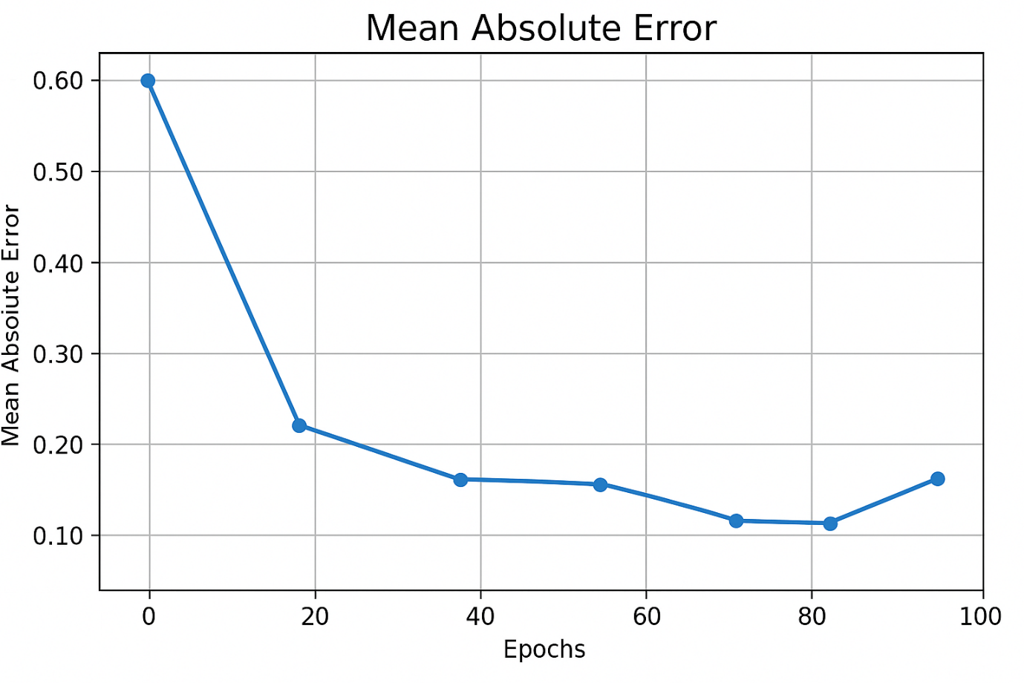
Lab 9

Lab 10

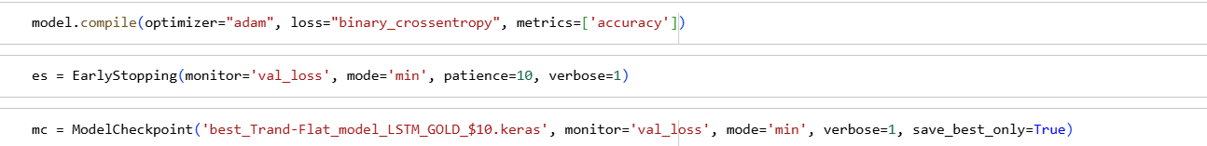
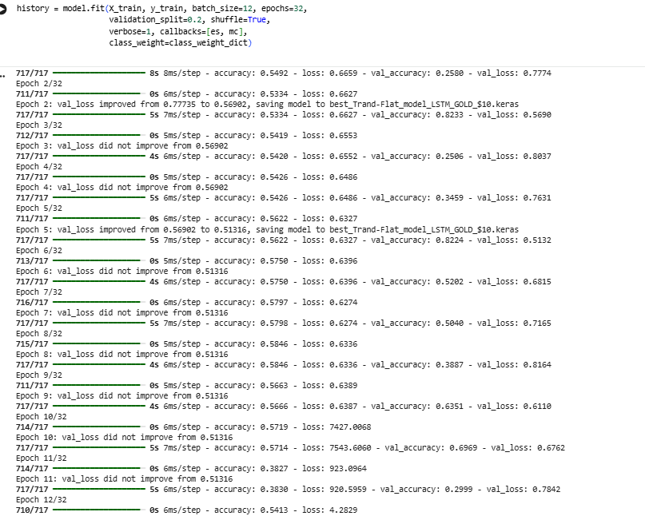
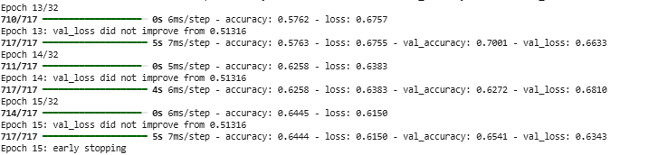
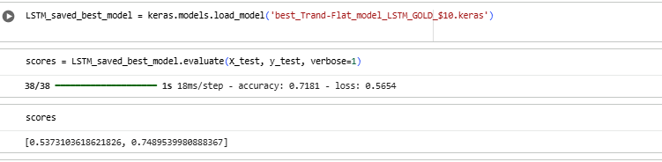
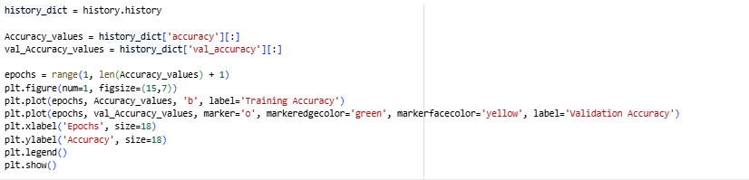
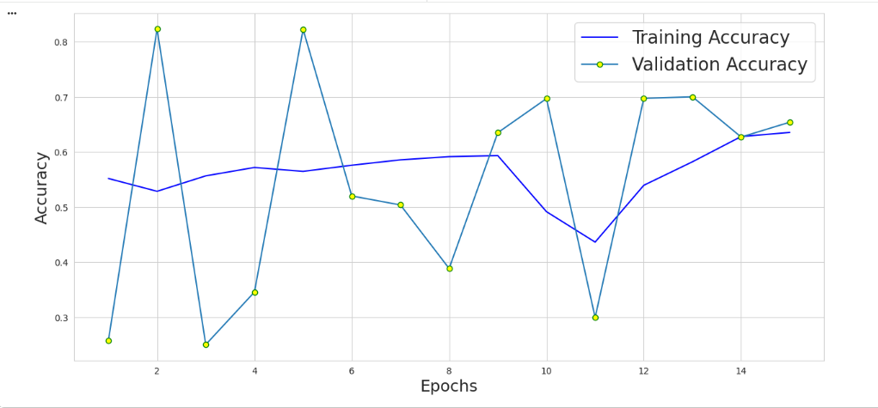

Lab 11

Lab 12

